**Beyeme Edou Jenathan**

**TCPDump File Analyzer User Guide**

**Introduction**

Welcome to the TCPDump File Analyzer application! This tool allows you to upload and analyze TCPDump files to gain insights into network traffic, protocols, IP addresses, and TCP flags. The application provides an easy-to-use interface for uploading files, viewing analysis results, and contacting the developer for support.

**Features**

* **Upload TCPDump Files:** Easily upload TCPDump files for analysis.
* **Traffic Analysis:** Visualize network traffic over time.
* **Protocol Distribution:** View the distribution of network protocols.
* **IP Address Analysis:** Analyze the top source and destination IP addresses.
* **TCP Flags:** Examine the distribution of TCP flags.
* **Contact Form:** Reach out to the developer for support or inquiries.

**How to Use the Application**

**Prerequisites**

Before you start using the TCPDump File Analyzer application, ensure you have the following prerequisites:

1. **Python**: Make sure Python is installed on your system. You can download it from [python.org](https://www.python.org/downloads/).
2. **Flask**: Install Flask, a micro web framework for Python, by running the following command:

bash

pip install flask

1. **Pandas**: Install Pandas, a powerful data analysis library, by running:

pip install pandas

1. **Matplotlib**: Install Matplotlib, a plotting library, by running:

pip install matplotlib

1. **tkinter**: Tkinter is usually included with Python. If not, you can install it via your package manager (e.g., sudo apt-get install python3-tk on Ubuntu).
2. **VS Code**: It is recommended to use Visual Studio Code (VS Code) for developing and running the application. You can download it from [code.visualstudio.com](https://code.visualstudio.com/).

**Installation**

Follow these steps to set up the application:

1. **Clone the Repository**: Clone the project repository from GitHub:

bash

git clone <https://github.com/BEYEME-SA105/compte-rendu.git>

app.py

1. **Set Up the Virtual Environment** (optional but recommended):

bash

python -m venv venv

source venv/bin/activate # On Windows, use `venv\Scripts\activate`

1. **Install Required Packages**:

bash

pip install flask pandas matplotlib

1. **Prepare the Directory Structure**:
   * Create a folder named static and place your jojo.jpg (photo of the developer) and favicon.ico (site icon) inside it.
   * Create a folder named templates and place the index.html and contact.html files inside it.

**Usage**

**Step 1: Running the Application**

1. Open VS Code and navigate to the project directory.
2. Run the Flask application using the following command:

python app.py

**Step 2: Access the Application**

Open your web browser and navigate to the application URL provided by your administrator. **http://127.0.0.1:5000**

**Step 3: Upload a TCPDump File**

1. On the homepage, click on the "Choose File" button.

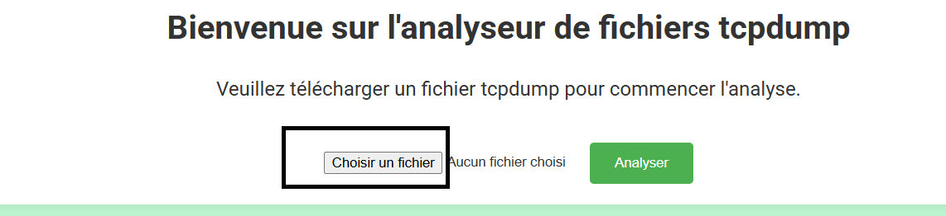

1. Select the TCPDump file you want to analyze from your computer.
2. Click the "Analyze" button to upload and start the analysis.

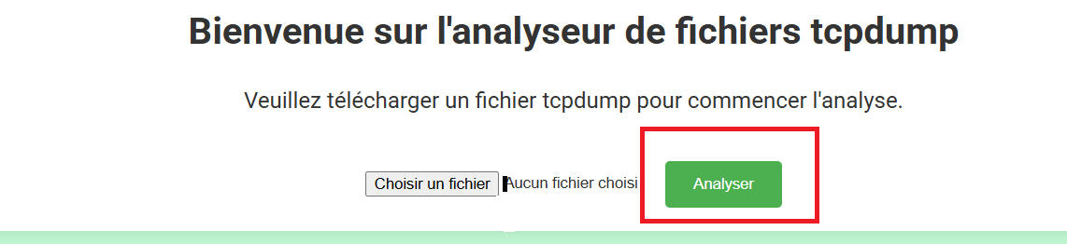

**Step 4: View Analysis Results**

After the file is uploaded and analyzed, the results will be displayed on the page. You can view various charts and graphs that provide insights into the network traffic.

**Traffic Over Time**

* This graph shows the network traffic over time, allowing you to see peaks and troughs in activity.

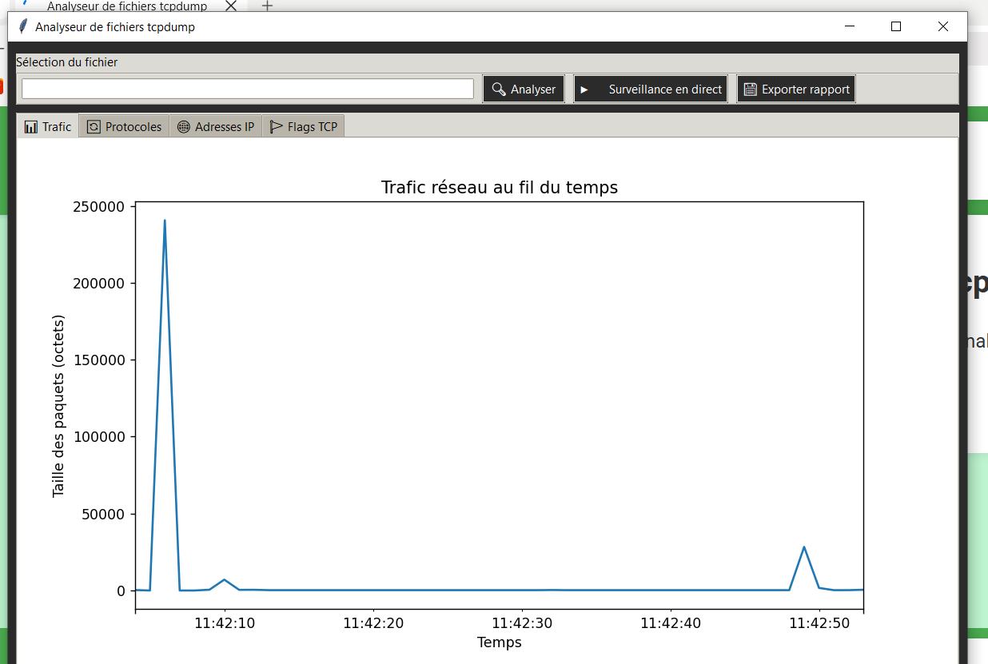

**Protocol Distribution**

* This pie chart illustrates the distribution of different network protocols in the captured traffic.

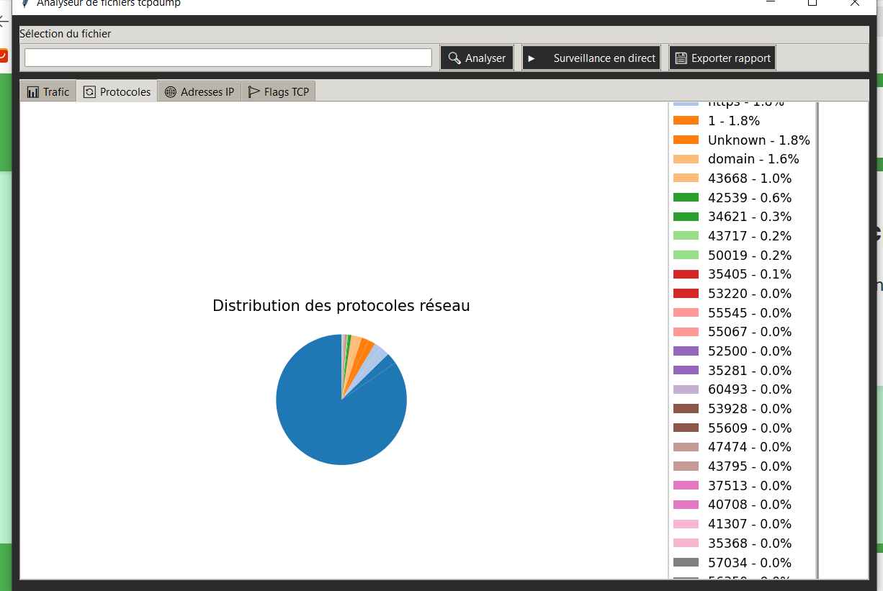

**IP Address Analysis**

* View the top source and destination IP addresses and their respective packet counts.

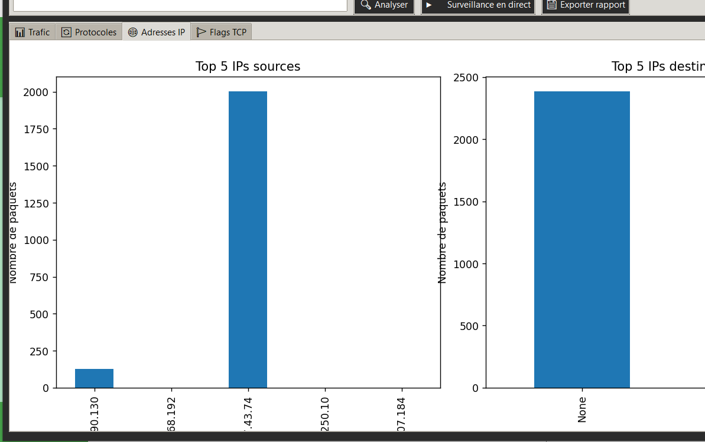

**TCP Flags**

* Examine the distribution of TCP flags in the captured traffic.

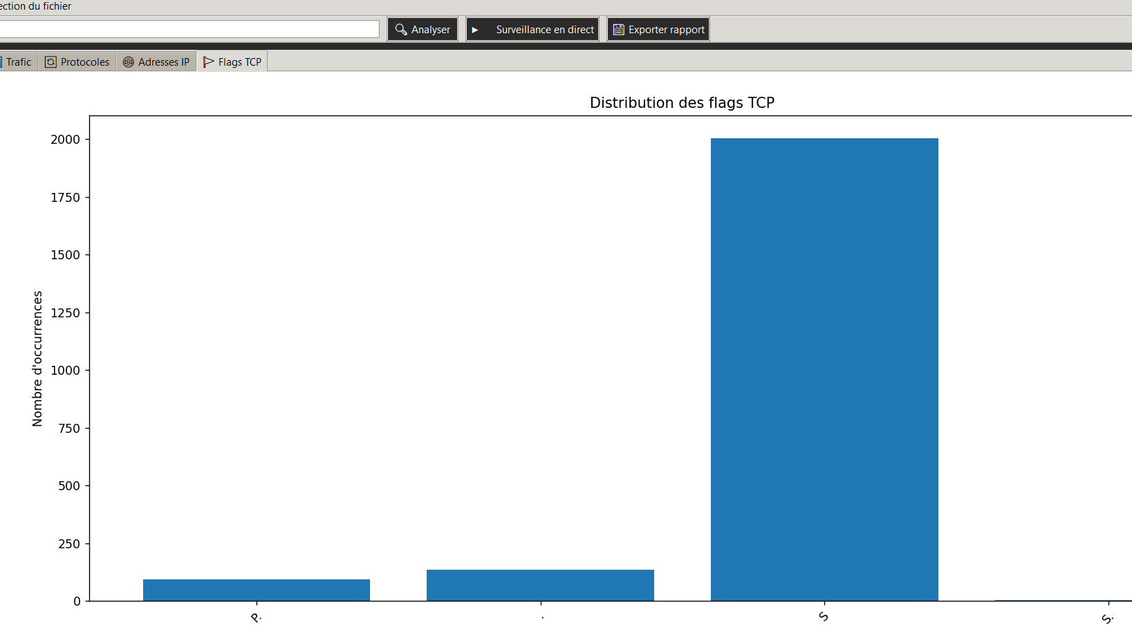

**Step 5: Contact the Developer**

If you have any questions, issues, or feedback, you can contact the developer directly from the application.

1. Navigate to the "Contact" page by clicking on the "Contact" link in the navigation bar.

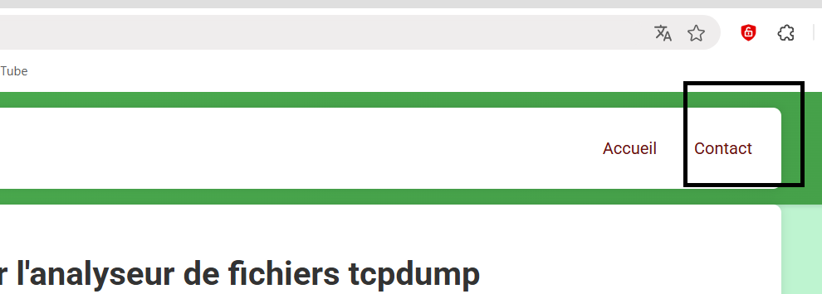

1. Fill out the contact form with your name, email address, and message.

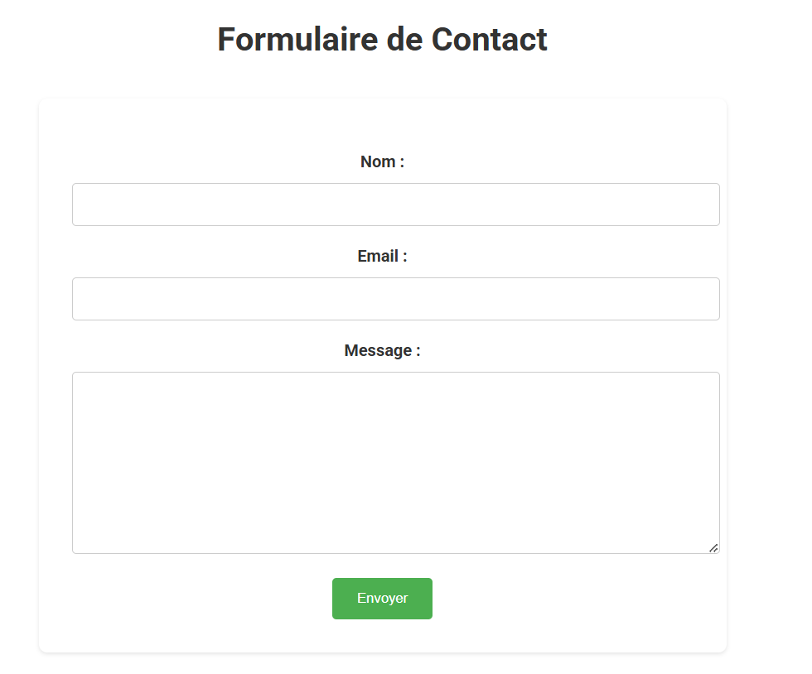

1. Click the "Send" button to submit your inquiry.

**Additional Information**

* **File Requirements:** Ensure that your TCPDump file is in a compatible format before uploading.
* **Data Privacy:** Uploaded files are processed securely and are not stored permanently.

**Troubleshooting**

* **File Upload Issues:** If you encounter issues uploading a file, ensure that the file is not corrupted and is in the correct format.
* **Analysis Errors:** If the analysis fails, try re-uploading the file or contact the developer for assistance.

**Contact Information**

For further assistance or inquiries, please contact the developer:

* **Name:** BEYEME EDOU jenathan
* **Email:** beyemejonathan@gmail.com
* **Phone:** +33 6 65676172

Thank you for using the TCPDump File Analyzer application!